**Visualisation:** *Vegans, vegetarians, fish-eaters and meat-eaters in the UK show discrepant environmental impacts*.

**Created by**: Chu-Yi Chung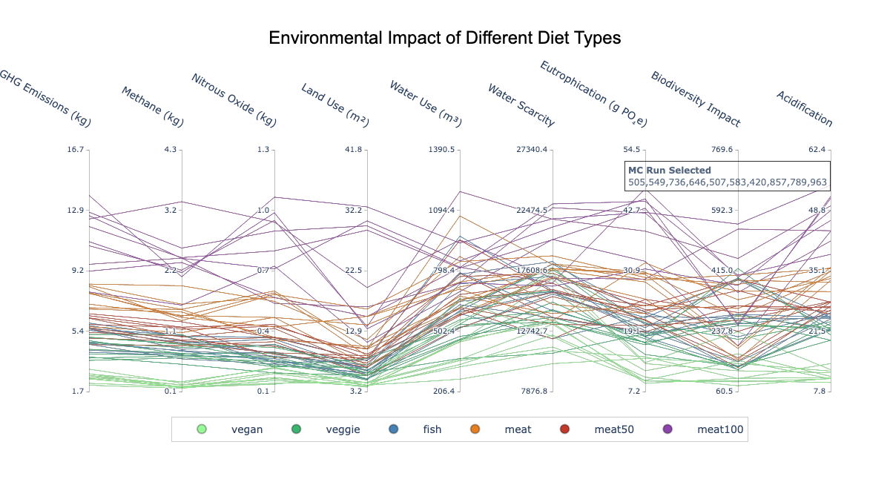

**Visual Design Type**: Parallel coordinates

**Name of Tool:** Plotly Graphing Library for Python (<https://plotly.com/python/>)

**Diet Groups:** vegan, veggie, fish, meat, meat50, meat100

**Variables:** All measurements provided in the original dataset are included - GHG emissions, methane, nitrous oxide, land use, water use, water scarcity, eutrophication, biodiversity loss, acidification.

**Visual Mapping:**

1. **Coordinate Axes:** Each axis represents a metric used to measure environmental impact of diets. The labels on top of each axis indicate the metric name and unit.
2. **Color:** Each color represents one diet group. The legend at the bottom of the graph clearly indicates the identity of each diet group.
3. **Scale:** Each axis uses its own scale since the metrics employ different units of measurement. The scale ranges are derived from the minimum and maximum values of each metric across all diet groups, with padding added based on the mean standard deviation across groups. This padding enhances readability and makes relationships between diet groups more discernible.
4. **Annotation:** The annotation in the top right indicates the set of ten Monte Carlo experiments used to generate this graph. While the original dataset contains 1000 experiment runs, the script randomly selects 10 for plot generation to improve readability.

**Data Preparation:**

* This plot presents condensed data from the original dataset. For each Monte Carlo experiment, all data points within each diet group are aggregated into a single row. Age groups and genders are excluded from this visualization, with each column displaying the mean value of all aggregated rows.

**Unique Observation:**

* The plot shows that there is a large discrepancy within meat-consuming diets. This is surprising because my initial assumption was that the consumption of meat would create a clear divide in most metrics. This observation suggests the quantity of meat consumed has more of an impact on the environment than the inclusion of meat in one’s diet. This observation concurs with the paper’s findings.

**URL to Source Code:**

* <https://github.com/spchung/ResearchMethodsCW2>

**References:**

Scarborough, P., Clark, M., Cobiac, L. *et al.* **Vegans, vegetarians, fish-eaters and meat-eaters in the UK show discrepant environmental impacts.** *Nat Food* 4, 565–574 (2023). https://doi.org/10.1038/s43016-023-00795-w